

TCAT PREVENT STATEMENT
Adopted by: Appleton Thorn Primary
Purpose and Commitment
At The Challenge Academy Trust (TCAT), we are committed to safeguarding and promoting the welfare of all our pupils. As part of this commitment, we actively support the government’s Prevent strategy to protect children and young people from the risk of radicalisation and extremism.
Understanding Prevent
The Prevent strategy is part of the UK’s counter-terrorism strategy, CONTEST. Its aim is to stop people becoming terrorists or supporting terrorism. In schools and colleges, this means safeguarding pupils from extremist ideologies and ensuring they are equipped to challenge such views.
The Role of Schools in Prevent
Schools and colleges play a vital role in Prevent. They are uniquely placed to identify children at risk of radicalisation and to intervene early. Through education, pastoral care, and safeguarding systems, schools and colleges help pupils build resilience to extremist narratives and foster a culture of respect, inclusion, and critical thinking.
Curriculum and British Values
TCAT schools and colleges embed the promotion of British values across the curriculum. These values include:
- Democracy
- The rule of law
- Individual liberty
- Mutual respect and tolerance of different faiths and beliefs
Through subjects such as PSHE, citizenship, and humanities, pupils are encouraged to explore diverse perspectives, understand the importance of human rights, and develop the skills to challenge prejudice and discrimination.
We foster a culture of safety, acceptance, and tolerance, where pupils feel valued and supported. Our curriculum is designed to promote:
- Critical thinking and respectful debate
- Understanding of different cultures and beliefs
- Empathy and emotional literacy
- Resilience against harmful ideologies
TCAT Approach
Across TCAT, we take a proactive and preventative approach to safeguarding. Our Prevent strategy is embedded within our wider safeguarding and child protection policies and practices. We ensure that:
- Staff are trained to identify signs of radicalisation and know how to respond appropriately
- Pupils are educated through a broad and balanced curriculum that promotes British values, critical thinking, and respectful debate
- Concerns are reported and acted upon using established safeguarding procedures, including referrals to the Channel programme where appropriate
- Online safety is prioritised, with robust filtering and monitoring systems in place to protect pupils from extremist content
- Partnerships with external agencies such as the police, local authority, and safeguarding boards are maintained to ensure a coordinated response
Definitions from KCSIE
To support clarity and consistency, TCAT adopts the following definitions from Keeping Children Safe in Education:
- Terrorism: An action that endangers or causes serious violence to a person/people; causes serious damage to property; or seriously interferes or disrupts an electronic system. The use or threat must be designed to influence the government or to intimidate the public and is made for the purpose of advancing a political, religious, or ideological cause.
- Extremism: The vocal or active opposition to our fundamental values, including democracy, the rule of law, individual liberty, and mutual respect and tolerance of different faiths and beliefs. This also includes calls for the death of members of the armed forces.
- Radicalisation: The process by which a person comes to support terrorism and extremist ideologies associated with terrorist groups.
Key Guidance and Resources
TCAT schools operate in line with the following statutory guidance:
- Prevent Duty Guidance: England and Wales (2023)
- Keeping Children Safe in Education (KCSIE) 2025
- Working Together to Safeguard Children (2023)
Monitoring and Review
TCAT regularly review our safeguarding policies, including Prevent measures, to ensure they remain effective and responsive to emerging threats. Training is updated every 2 years for all staff, and safeguarding audits include Prevent compliance.
Making Referrals to Prevent
If a member of staff has a concern that a pupil may be at risk of radicalisation, they must follow the school’s safeguarding procedures and report the concern to the Designated Safeguarding Lead (DSL).
The DSL will assess the concern and, if appropriate, make a referral to the Channel programme, a multi-agency safeguarding initiative that supports individuals vulnerable to being drawn into terrorism.
Referrals may also be made directly to the Local Authority Prevent Team or via the Police Prevent Officer, depending on local arrangements. All referrals are handled sensitively and in line with data protection and safeguarding protocols.
Staff should never attempt to investigate concerns themselves but must act swiftly and responsibly to ensure the safety of the pupil and wider community.

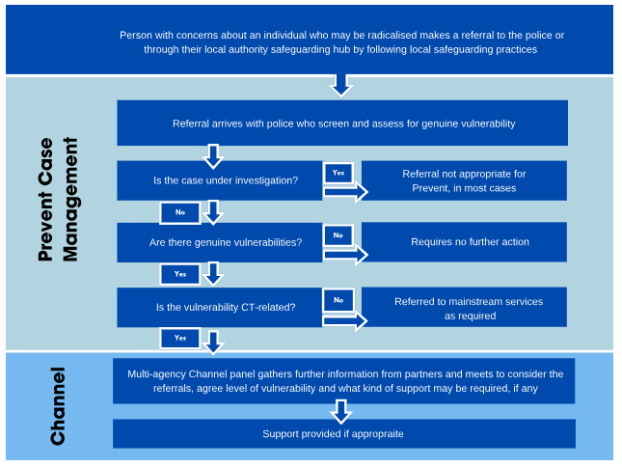
Making a referral to Prevent - GOV.UK (www.gov.uk)

