**Meal Times at Starlings Report**

Summary of parent responses (13) who were asked their thoughts on the current 3 week menu; 1-keep, 2-don't mind, 3-replace.

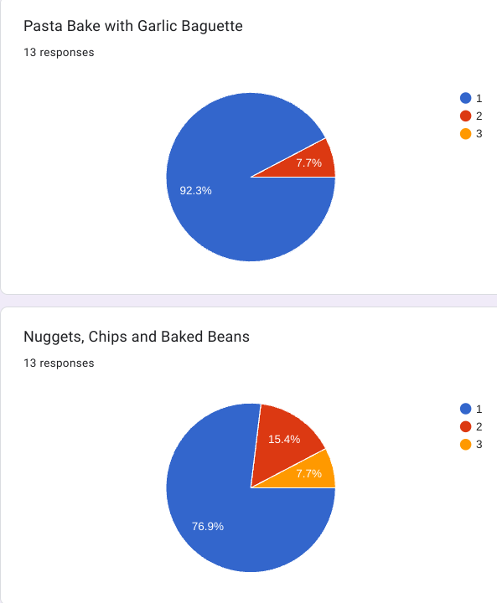 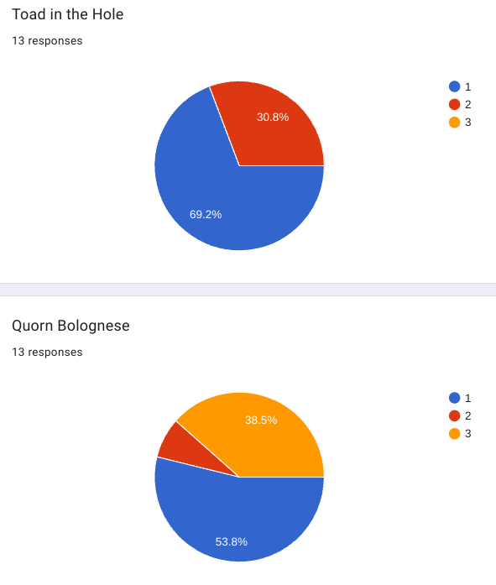

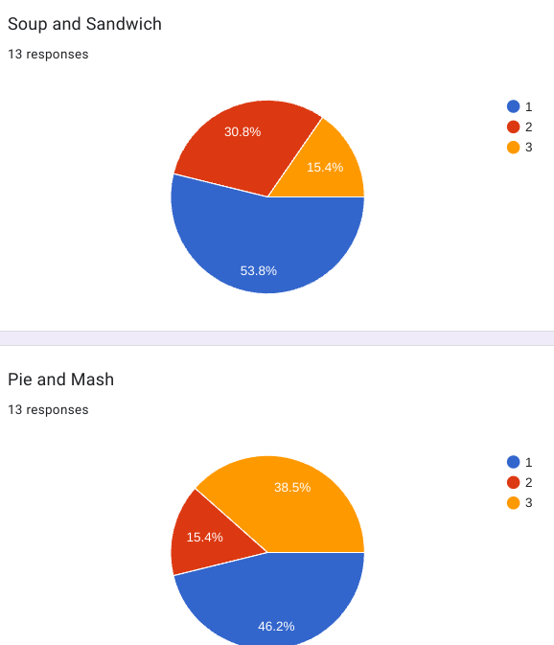 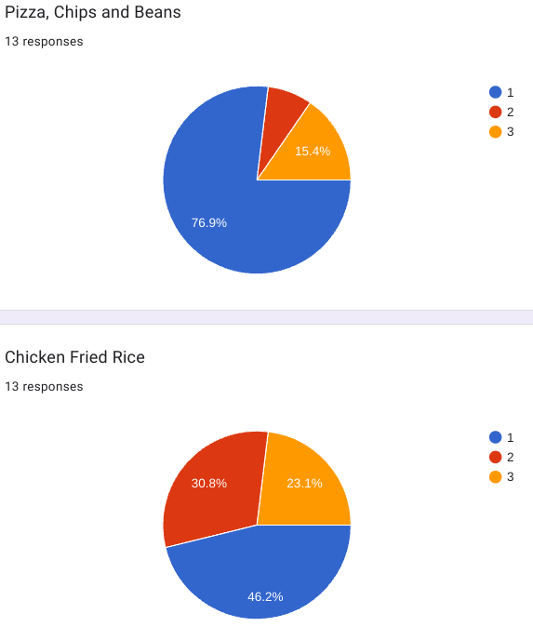

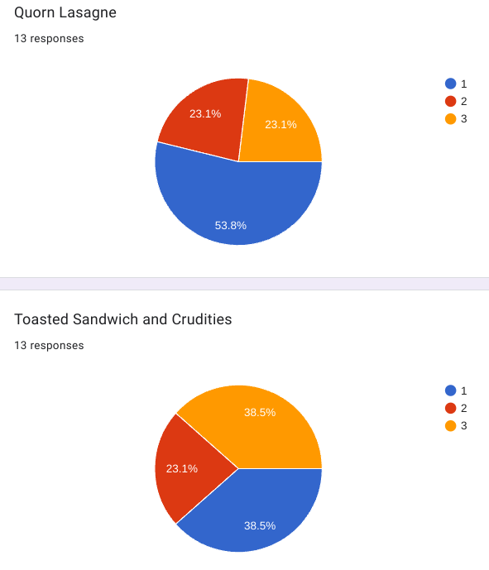 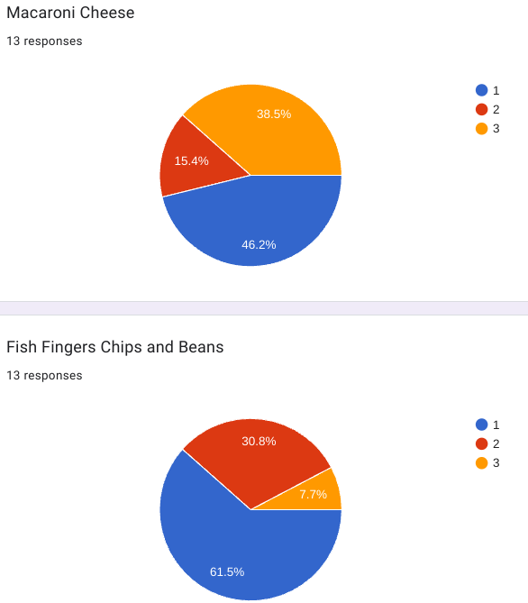

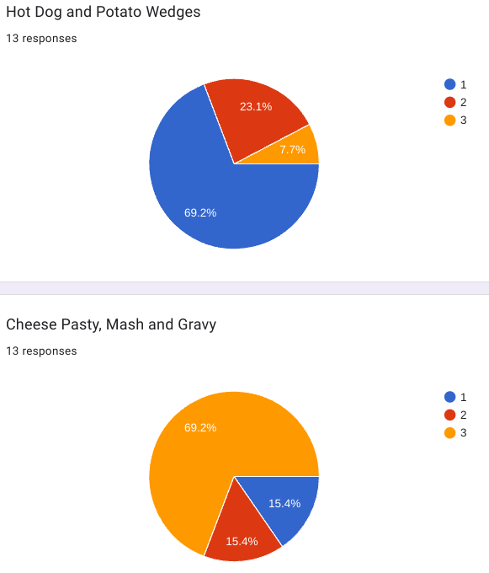 

Requests for new meals such as curry and rice, burgers, chilli, carbonara and sausage and mash have been incorporated into our new menus.

We already serve meals 'deconstructed' when possible and will continue to do this where we can to make mealtimes easier for those with aversions. Remember, Starlings must provide a balanced meal, however it is up to the child how much of it they eat.

Comments regarding "more healthy food" I would like to address. Chips and other "freezer food" are offered once a week and served alongside them is always a portion of vegetables **and** a side salad. We will continue to offer these meals as they are the highest rated with the children.

This survey was also conducted with the children (12) during Starlings sessions, the results of which can be found below:

| Meal | 1 - Keep it | 2 - Don't mind | 3 - Change it |
| --- | --- | --- | --- |
| Pasta Bake & Garlic Bread | 50% | - | 50% |
| Nuggets, Chips & Beans | 100% | - | - |
| Toad in the Hole | 33% | 17% | 50% |
| Quorn Bolognese | 66% | 17% | 17% |
| Soup & Sandwich | 66% | 17% | 17% |
| Pie & Mash | 25% | 17% | 58% |
| Pizza, Chips & Beans | 100% | - | - |
| Chicken Fried Rice | 8% | 17% | 75% |
| Lasagne | 59% | 8% | 33% |
| Toasted Sandwiches | 42% | 8% | 50% |
| Macaroni Cheese | 66% | 17% | 17% |
| Fish Fingers, Chips & Beans | 92% | - | 8% |
| Hot Dog & Potato Wedges | 75% | 8% | 17% |
| Cheese Pasty, Mash & Gravy | 25% | 8% | 67% |

Following consultation with the children, those who chose option 2 have been placed with the majority. Where there was an even split, parent views have been added in to decide the final outcome.

Our new menu effective from Monday 10th June is as follows:

| WEEK ONE | | WEEK TWO | | WEEK THREE | |
| --- | --- | --- | --- | --- | --- |
| MON | Sausage, Mash, Peas & Gravy | MON | Cowboy Pie* | MON | Chicken Tacos |
| TUE | Spaghetti Bolognese | TUE | Pizza, Hash Brown & Beans | TUE | Burger, Wedges & Beans |
| WED | Pasta Bake & Garlic Bread | WED | Chilli, Rice & Tortillas | WED | Lemon Chicken & Couscous |
| THU | Nuggets, Chips & Beans | THU | Carbonara & Garlic Bread | THU | Curry & Rice with Naan |
| FRI | Soup and Toastie | FRI | Macaroni Cheese | FRI | Hot Dog & Mini Waffles |

*Cowboy Pie - Sausages, Beans, Mashed Potato and Cheese.