**“A great service.”**

**Survey Report 7th May 2024**

The survey was distributed through Class Dojo in March and April of 2024. There were 16 respondents in total. The following is a report of the feedback received.

**Overall, how satisfied are you with Starlings?**

94% of respondents reported that they are satisfied (50%) or very satisfied (44%) with the services provided. One respondent (4%) said they were somewhat dissatisfied.

**How well does Starlings meet your needs?**

All but one response indicated that the service meets the needs of our families very well (50%) or somewhat well (44%).

**How would you rate the quality of Starlings staff?**

100% rated the quality of the staff positively.

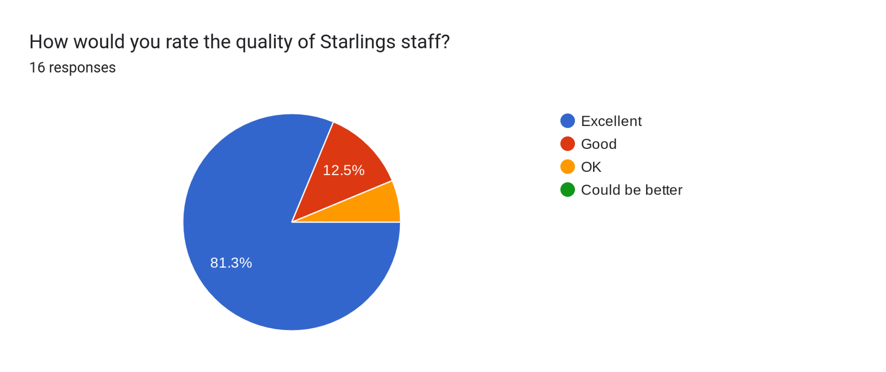

**How would you rate the quality of the meals on offer?**

69% of responses were positive about the menus, with 38% rating them excellent, 19% good and 13% OK. 31% feel the menus could be improved.

**How would you rate the activities on offer?**

All responses were positive in regards to the provided activities. 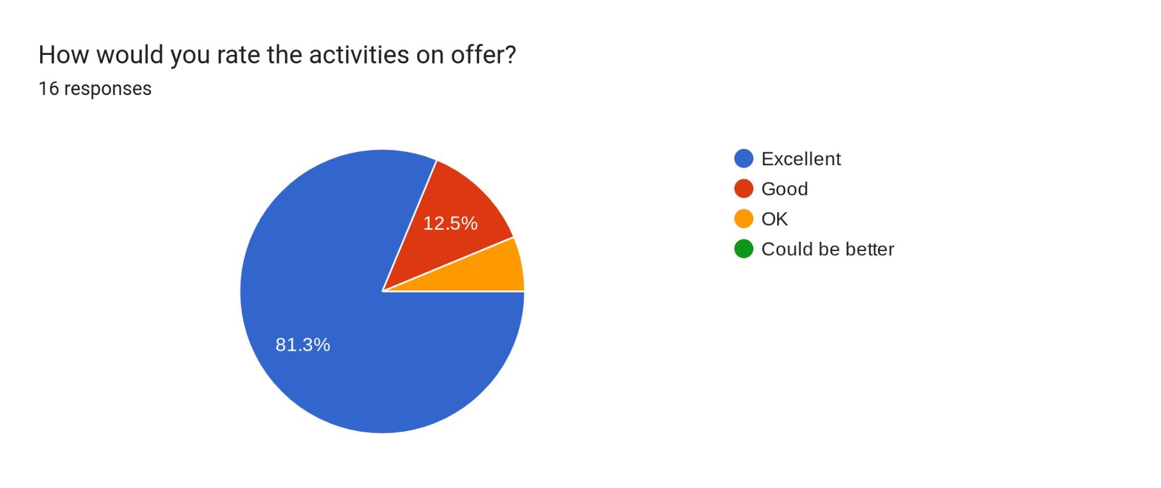

**How likely are you to recommend Starlings to others?**

94% of the responses indicated that they would recommend Starlings. 1 respondent said that they would not.

**Please tell us what you feel Starlings does well.**

The most common responses to this question referred to the positive experiences of their children and their engagement during sessions. Other comments describe the flexibility and availability of the service, and the ease with which places are booked, communication through ClassDojo and how staff listen to the children.

**Please tell us how you feel Starlings could improve?**

There were three common themes in response to this question; the improvement of the menus, outdoor equipment and holiday club.

Meals are not always to all tastes and requests for specific meals have been made. Increased access to outdoor equipment, especially for our older children, have been made. Comments about the holiday club refer to the extension of the daily opening times, the cost and minimum attendance and cancellation policy.

Other suggested improvements include a wider range of breakfast drinks, the possibility of a sibling discount, an ability to cancel places with notice and a reduced ticket to cover the first hour after school.

**Action Points**

1. An additional survey regarding the menus has been issued.

2. Milk and juice are now available at breakfast time.

3. We have purchased new outdoor equipment, for all children but with the older children particularly in mind.

4. Holiday club bookings arrangements will be analysed for possible further adaptations, however, session times will remain the same for the foreseeable future.

5. Financial analysis will be carried out to evaluate the impact of multi-child discounts, limited cancellations, and part-session tickets.

**Summary**

Another very positive set of responses once again highlights the amazing work of the staff who are making every effort to ensure children enjoy their time at Starlings. Recommendations for operational improvements continue to be the more negative aspects of parents’ feedback and as always the Starlings manager is committed to find ways in which these issues can be addressed.

Starlings would like to thank parents for taking the time to let us know their thoughts and we continue to value all feedback received from families.